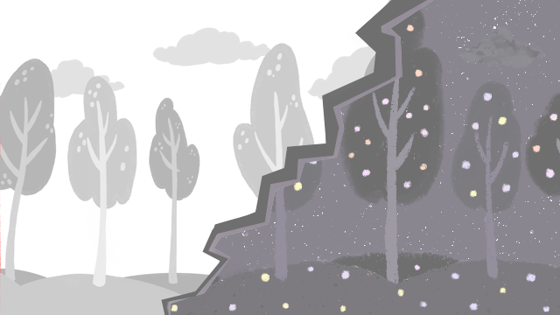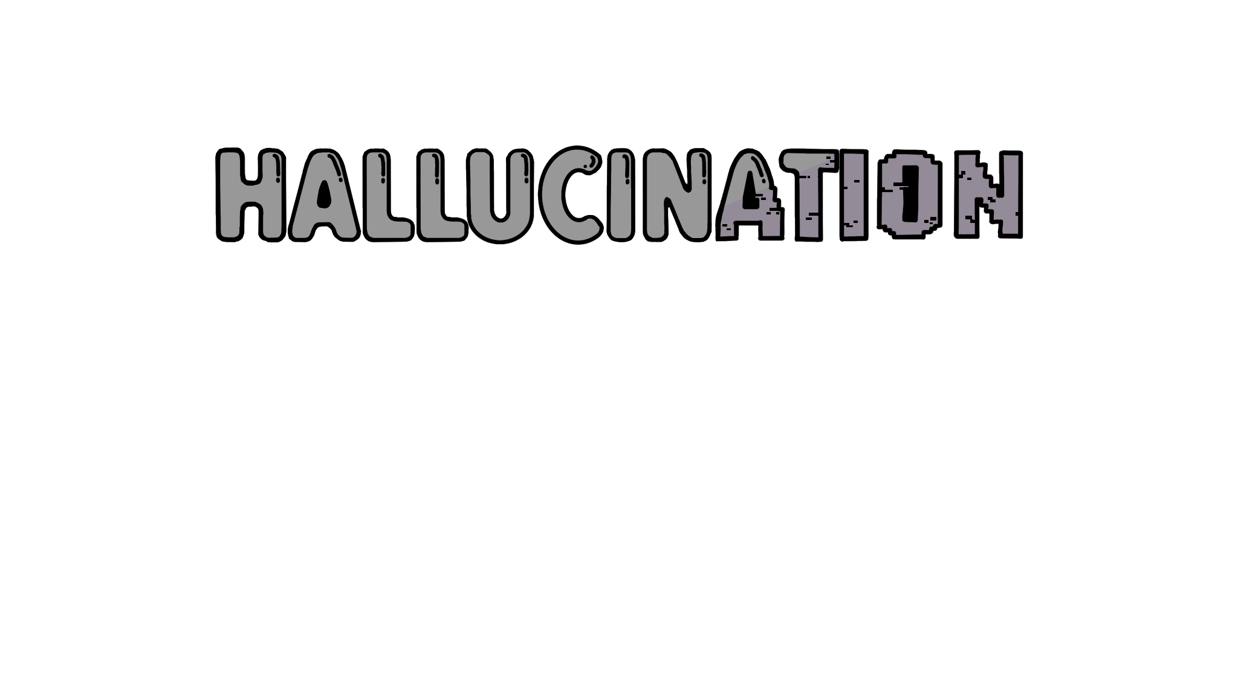

Game Design Final Report

Github Link: <https://github.com/seantsao00/Hallucination>

We can’t truly know what others are thinking,  
and we might not even be able to understand a little bit how they feel.

But still, through compassion, patience, and love,  
we can gradually accept each other and find a way to connect.

# Game Introduction

## Game Overview

The game allows players to switch between the fairy's hallucinated world and the bear's normal world, controlling each character in their respective realms. The player can experience different perspectives in the game, except during certain levels. In the fairy's world, dangerous obstacles appear, and the player must control the bear to clear these dangers or create pathways for the fairy to continue forward.

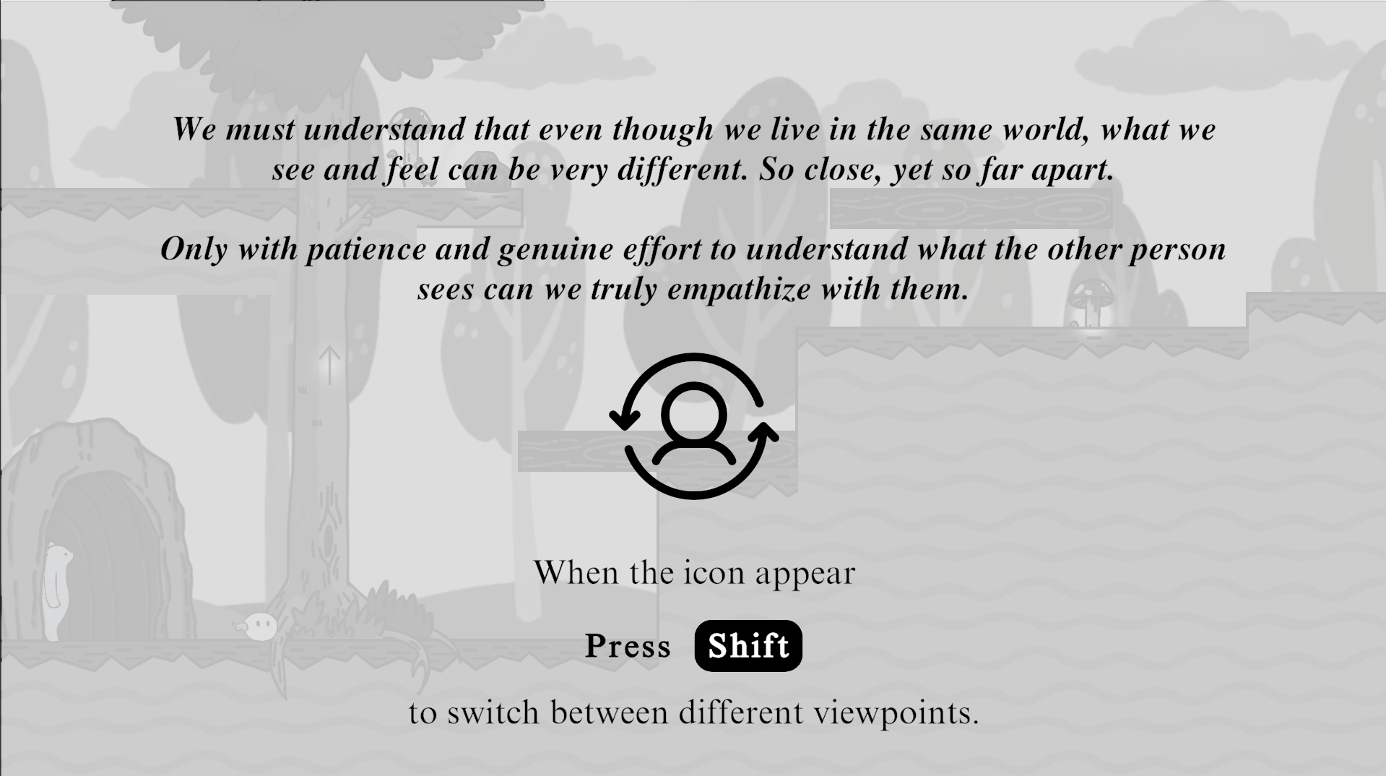

## Story Overview

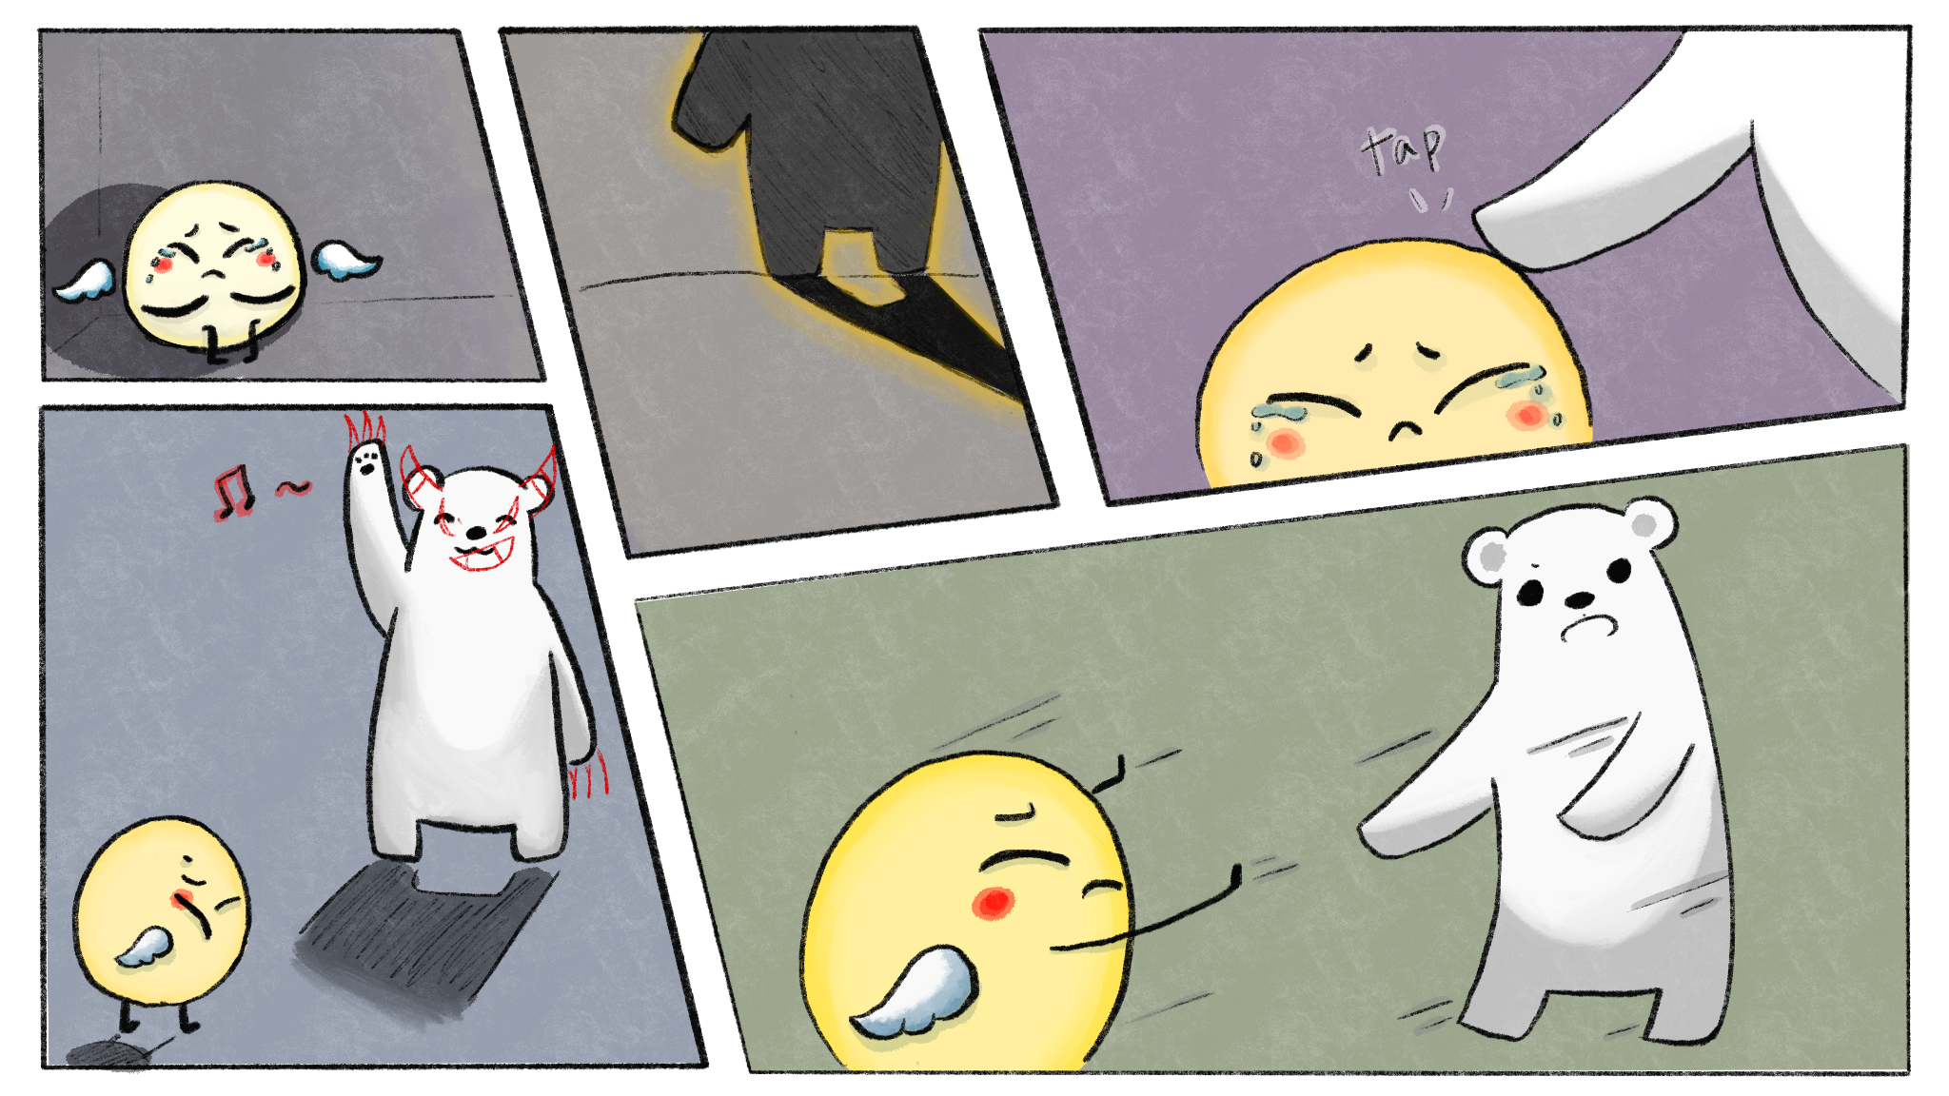

In a forest, there are two unlikely companions: a gentle, slow-moving bear and a mystical fairy. They share an unspoken bond, living side by side in harmony. The bear is calm and patient, while the fairy is fast, light, and full of life. But one day, something changes. The fairy begins to see the world differently, as if trapped in a distorted reality, perceiving the bear and everything around them as something dark and threatening.

The bear, confused and heartbroken, doesn't understand what's happening. The fairy's strange behavior and distorted perceptions leave the bear feeling helpless. Yet, despite the confusion and fear, the bear remains determined to reach the fairy, to understand what has happened, and to find a way to reconnect.

As the journey unfolds, the bear follows the fairy through their surreal world, attempting to help, even as the fairy runs away in fear, unable to comprehend the bear's intentions. With every step, the bear learns more about the fairy's hallucinatory world and begins to see glimpses of what the fairy experiences.

Through patience, compassion, and perseverance, the bear comes to realize that they may never fully understand the fairy's perception of the world, but that doesn't mean they can't help. The bear learns that the key to connection isn't in understanding every detail, but in accepting the other as they are, no matter how different or lost they might seem.

The story is about love, acceptance, and the beauty of sticking together even when the world feels incomprehensible. The bear may not be able to restore the fairy to how they were, but through their journey, they discover the power of being present and offering support, even without understanding everything. True connection, they learn, doesn't require fixing or changing; it only requires compassion, patience, and the willingness to be there for each other.

## Levels Overview

### The Journey Begins

*The bear is deeply confused, unable to comprehend why the fairy has changed so suddenly, why their once joyous companion now seems to fear them.*

*The fairy's hallucinations have trapped them in an altered reality, and they struggle to leave. The bear, despite not fully understanding the cause, is determined to help. The bear try to shield the fairy from dangers in their hallucinatory world.*

Introduce players to the basic movements for the fairy and the bear, as well as the interactive objects in the environment.

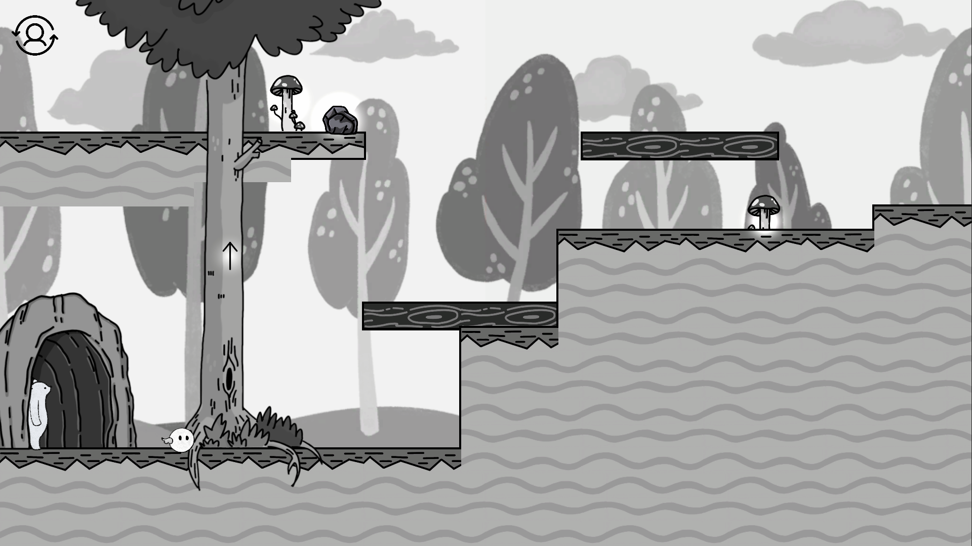 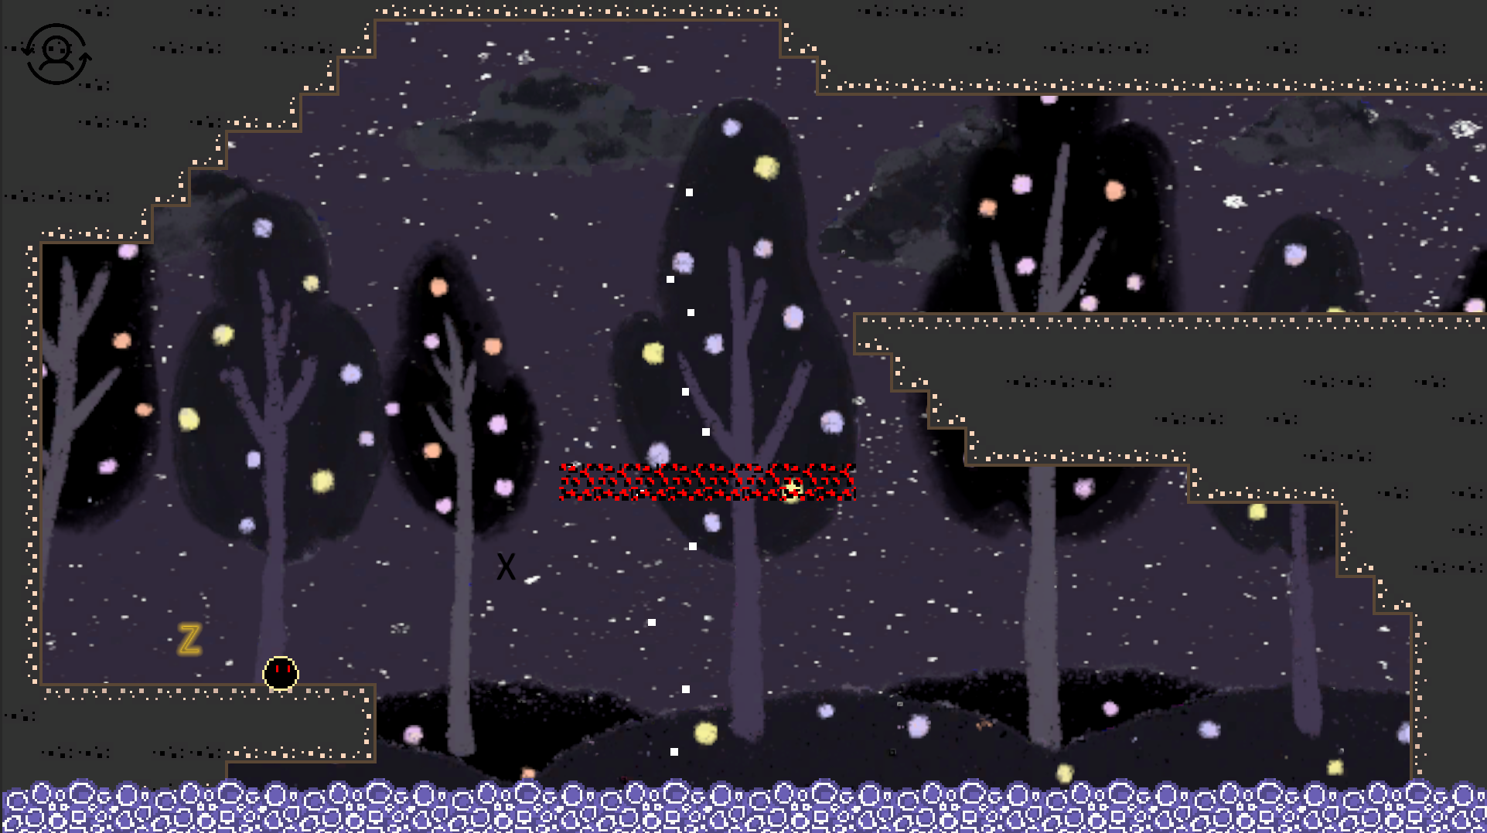

### Cable Car

*After leaving where they live, the fairy becomes trapped in a cable car due to its hallucination, trying to leave but unable to escape. The bear, tries to free the fairy from this entrapment. Though the bear doesn't fully understand the fairy's condition, the bear still try to help.*

*At this point, the bear's desperation grows. They yearn to restore the fairy to what they once were, to make everything as it was before. The bear feels an overwhelming desire to turn fairy back to what they once were.*

Familiarize players with additional mechanics, such as levers, lightbulbs, keys, and locks.

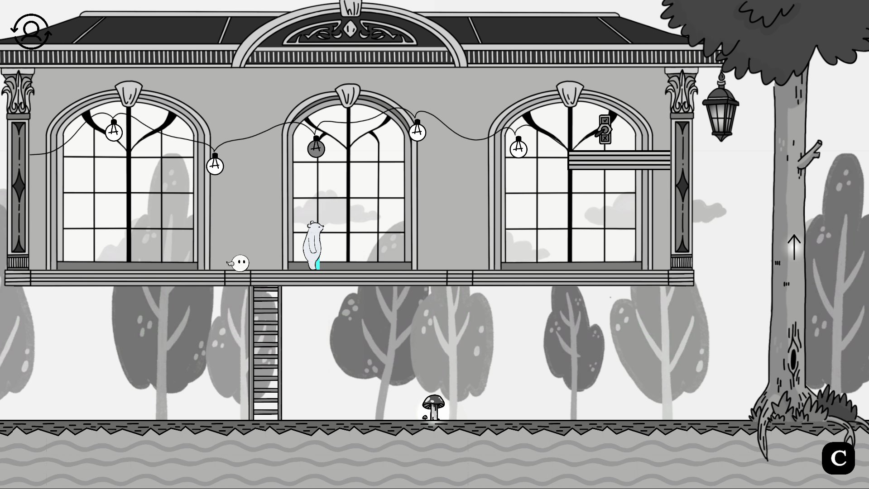 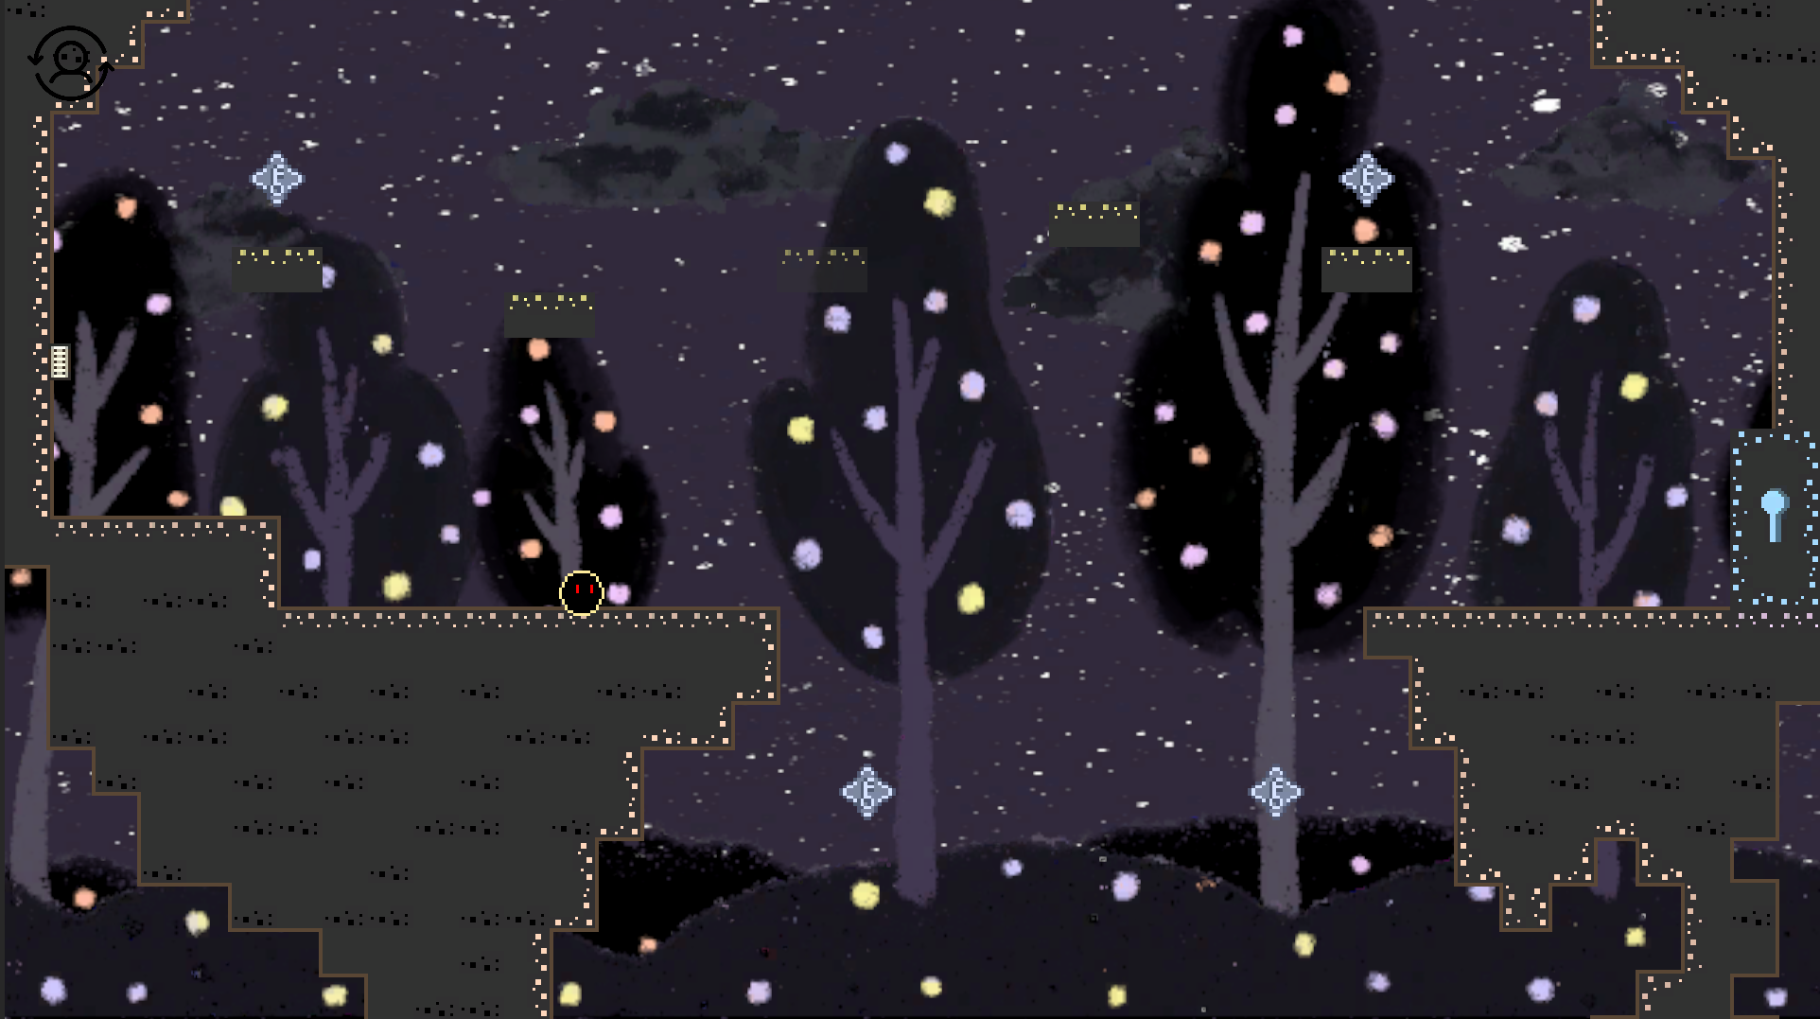

### Chase

*The fairy sees the bear as a dark, ominous monster chasing after they. The bear's intentions are misunderstood, and the fairy runs in fear, unaware that the bear is trying to help, not harm.*

*In these moments, the bear's dialogue becomes more heartfelt and emotional. The bear speaks not out of anger, but out of desperation, trying to convey the desire to help and to fix what's broken. The bear doesn't understand what the fairy sees, but there's a profound yearning to be back to what all things was.*

*After the player successfully pass the obstacles, the fairy and the bear entered a long gallery. As the slowly walk forward (the tension disappear), the bear begins to shift, realizing that perhaps they need to let go of the idea of fixing the fairy and instead learn to accept them as they are.*

In this level, the world-switching feature is locked and the player can only control the fairy. The player should control the fairy to perform a sprint (parkour), dodge obstacles and hazards, and evading the bear's chase, all while hearing the bear's voice calling out, pleading for the fairy to back to what they were. This level helps players to practice controlling the fairy.

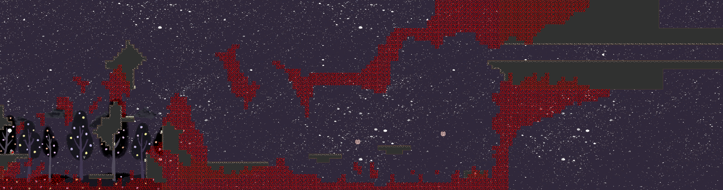

### Accept

*The bear's perspective starts to shift. As they begin to accept the fairy's change, the bear starts experiencing glimpses of the hallucinations that plague the fairy. They begin to understand, though imperfectly, what the fairy sees and feels --- an experience that is disorienting and difficult to comprehend.*

*Though the bear still doesn't fully understand the hallucinations, they realize that their journey isn't about returning the fairy to what they were before. It's about finding a way to move forward, together, and accepting the fairy as they are now. The bear understands that love and connection aren't about fixing others; it's about being there, offering support, and embracing one another in all their complexities.*

*By the end of the journey, the bear reaches a place of true acceptance. The bear and fairy no longer need to be the same as they were before. They no longer need to fix the past. What matters is that they can move forward, together, with patience, compassion, and a willingness to accept each other as they are.*

This is the main part of our game, it contains 3 levels. The player should utilize crystals to materialize imaginary objects near the bear from the bear's world in the fairy's world. Solve puzzles and progress through levels by combining control and logic.

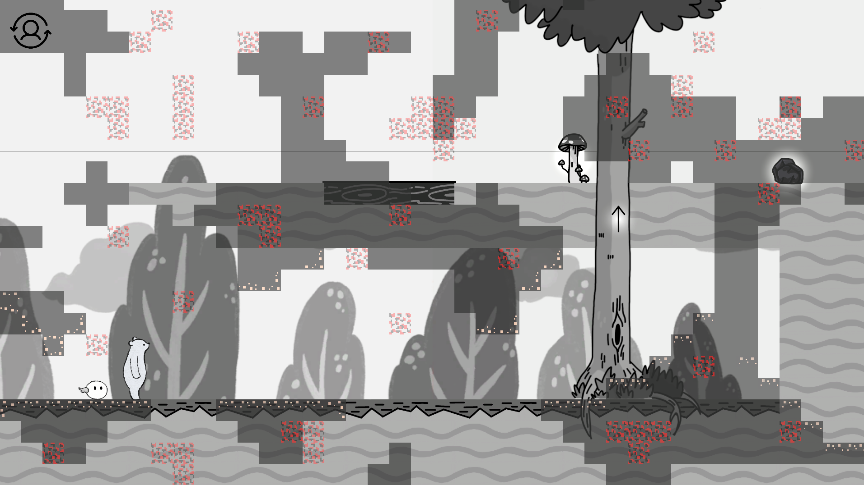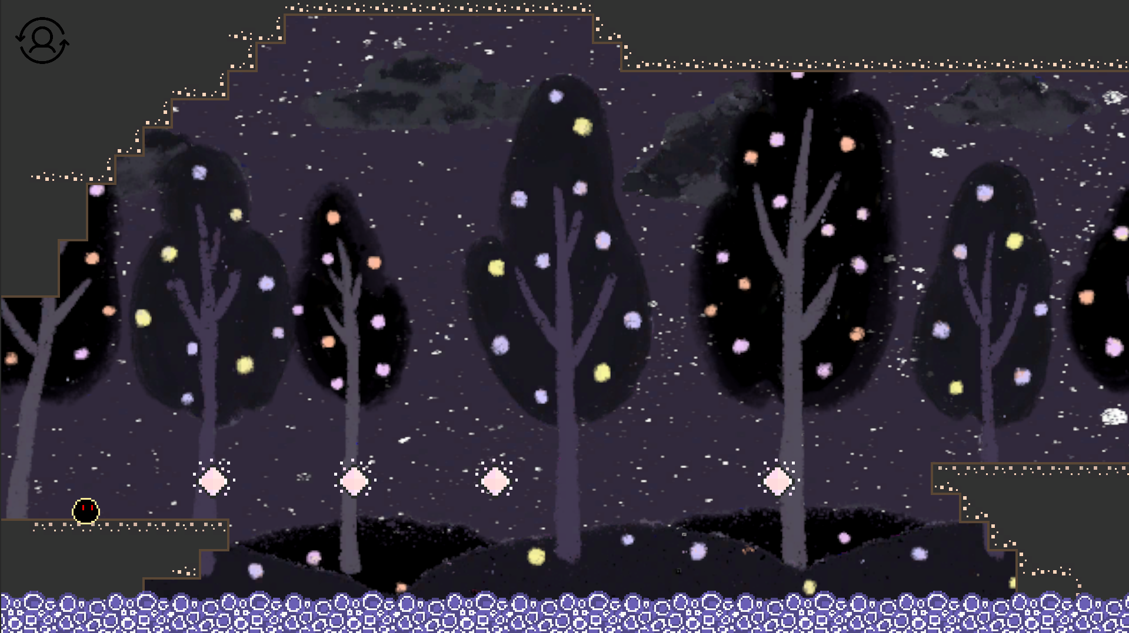

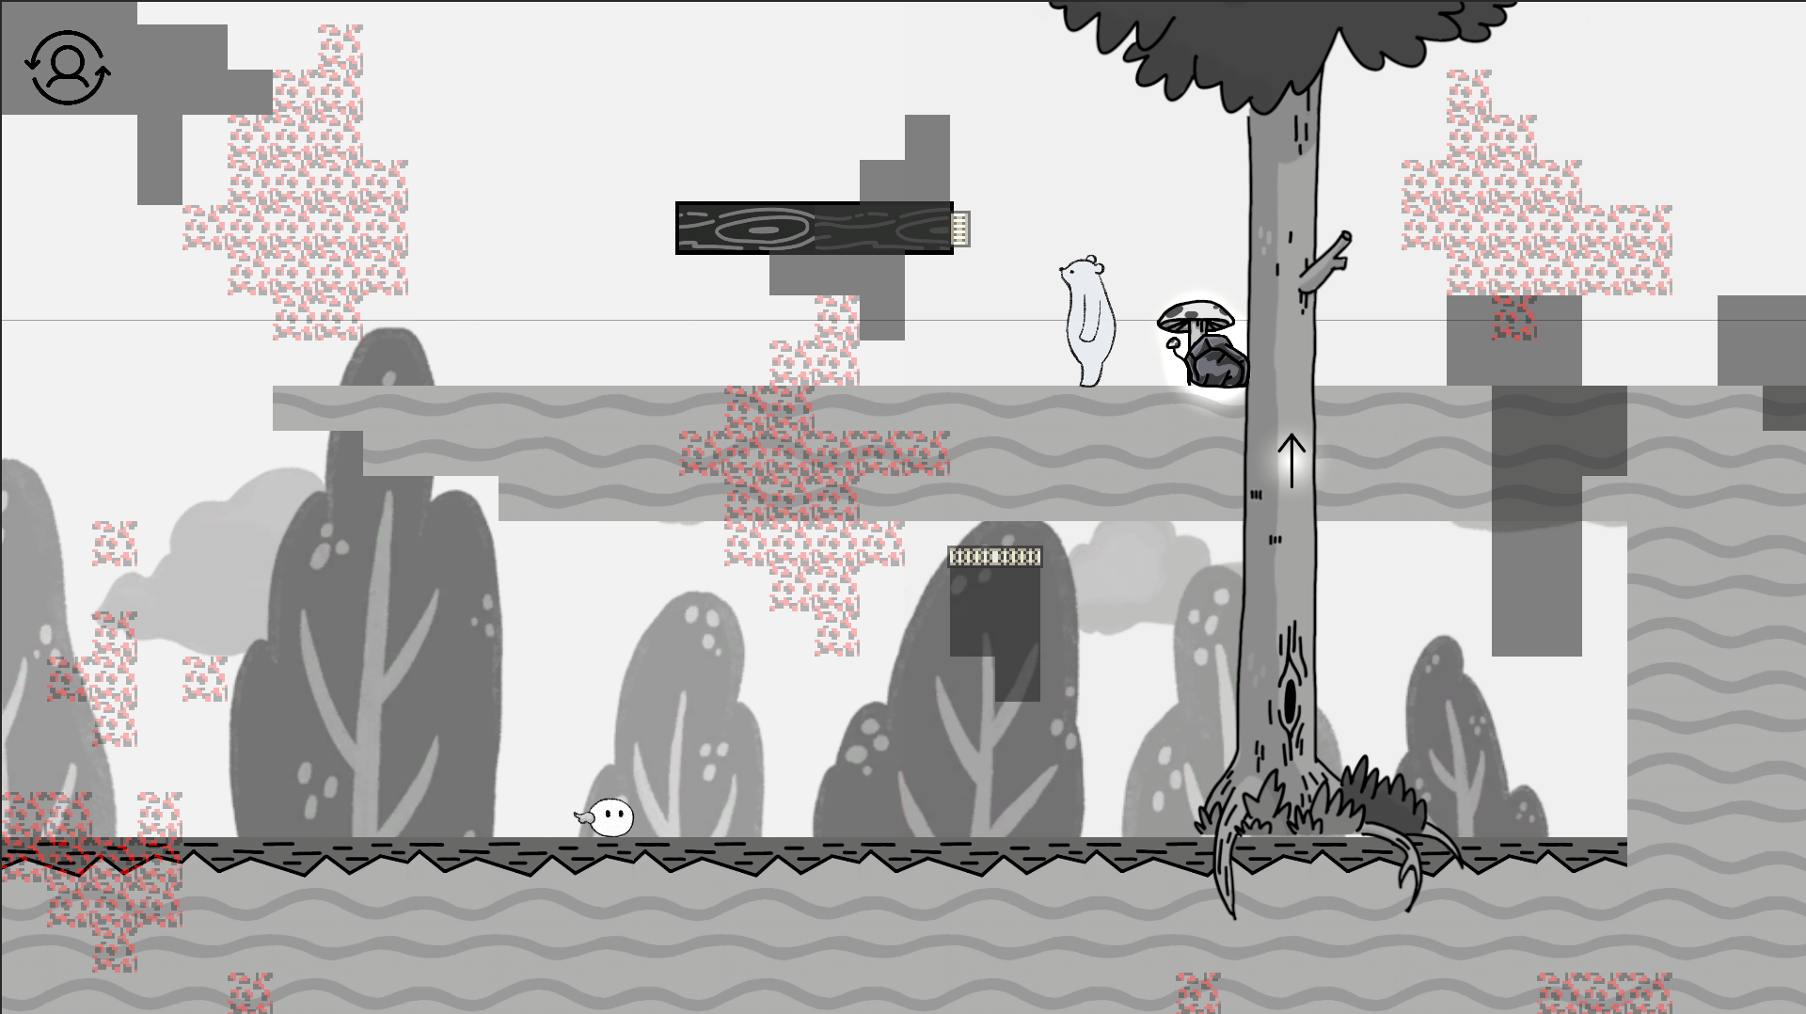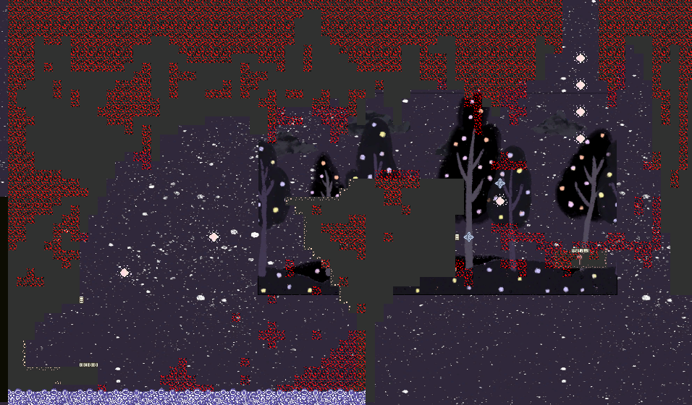

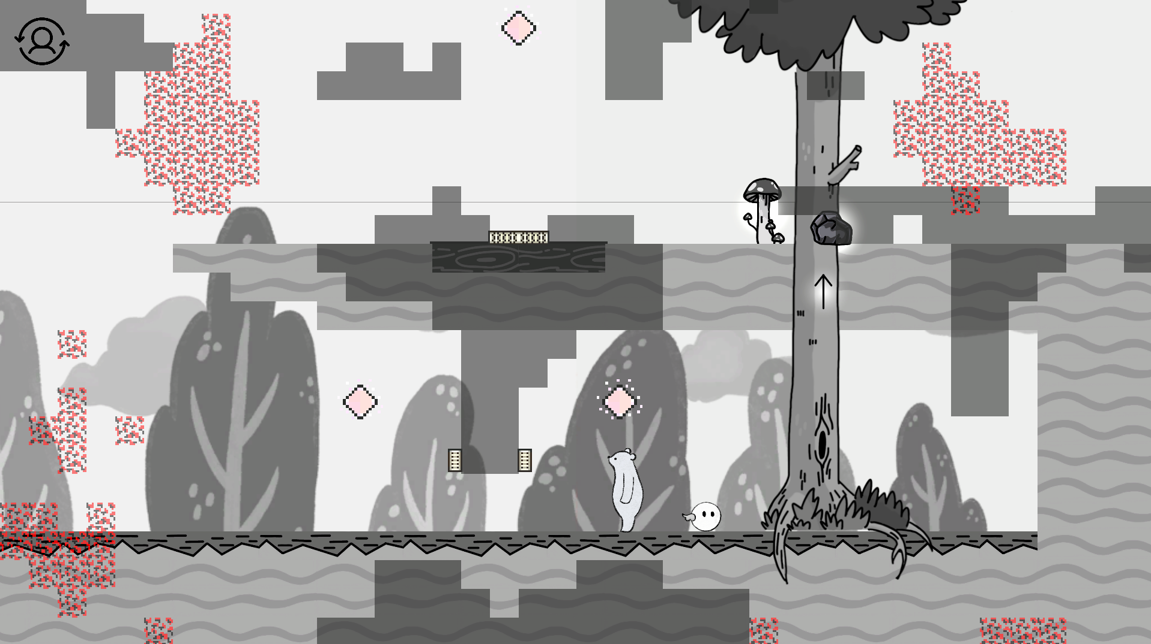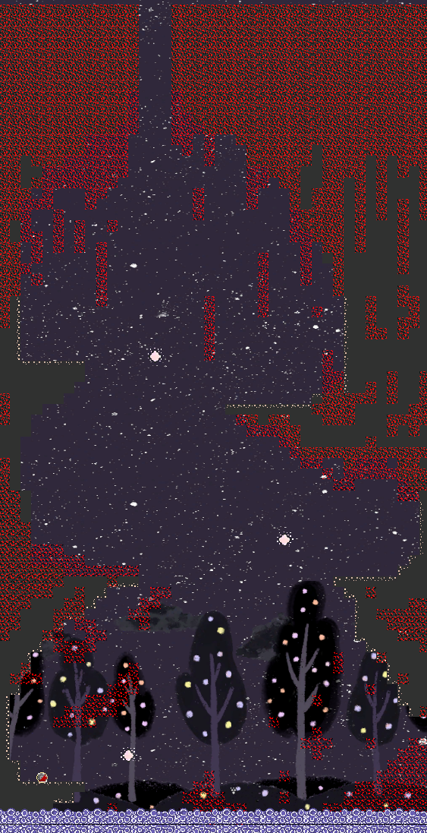

# Credit

## Game Design

洪銘德 shimeming

## Game Develop

洪銘德 shimeming　曹紹洵 seantsao00　劉丞浩 Howard_KNO3

## Art

陳愷欣 kxcathy　江承穎 una7100